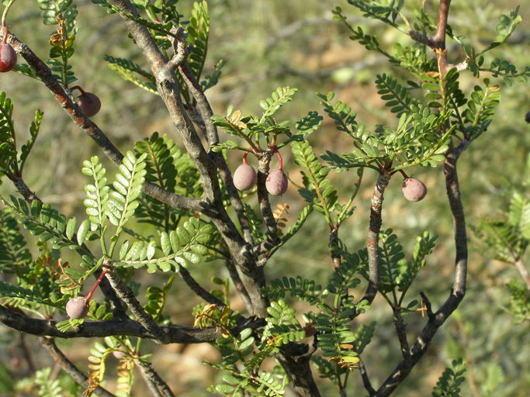

# **Elephant Tree**

*Bursera microphylla*

(<http://calphotos.berkeley.edu/imgs/512x768/0000_0000/0311/2435.jpeg>)

**Category:**

Shrubs

Trees

**Water Requirements:**

Drought-tolerant; suitable for xeriscaping

**Height:**

12-15 ft. (3.6-4.7 m)

**Spacing:**

20-30 ft. (6-9 m)

30-40 ft. (9-12 m)

over 40 ft. (12 m)

**Hardiness:**

USDA Zone 9a: to -6.6 °C (20 °F)

USDA Zone 9b: to -3.8 °C (25 °F)

USDA Zone 10a: to -1.1 °C (30 °F)

USDA Zone 10b: to 1.7 °C (35 °F)

**Sun Exposure:**

Full Sun

**Danger:**

[Unknown - Tell us](http://davesgarden.com/guides/pf/addoptions.php?pid=54929&namenum=5)

**Bloom Color:**

White/Near White

**Bloom Time:**

Mid Spring

**Foliage:**

Deciduous

**Soil pH requirements:**

6.1 to 6.5 (mildly acidic)

6.6 to 7.5 (neutral)

7.6 to 7.8 (mildly alkaline)

**Patent Information:**

Non-patented

**Propagation Methods:**

From semi-hardwood cuttings

From seed; direct sow outdoors in fall

**Seed Collecting:**

Allow seedheads to dry on plants; remove and collect seeds